­­­­­­­­­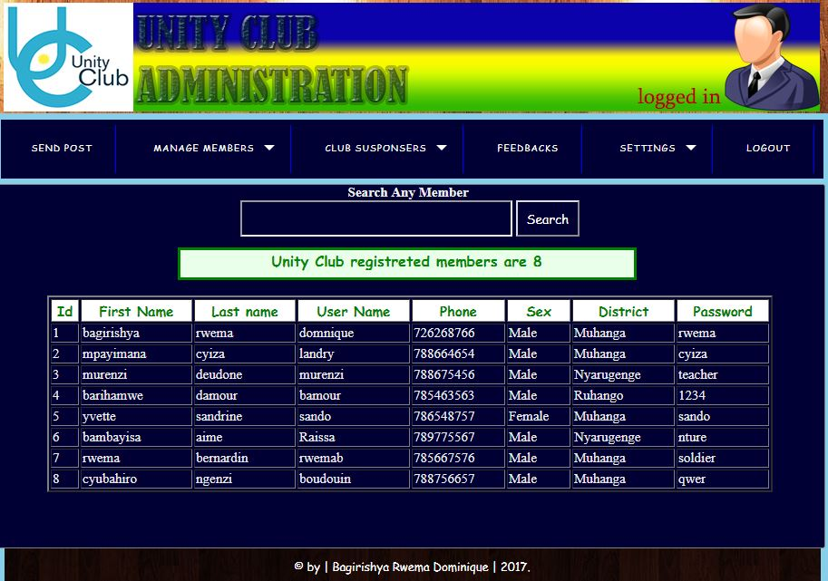

Figure 9 members list

*This figure representing the list of all members in our system. here this system is counting all of members After it displays the total (as it shown above).* ***Here is in administrator interface or (admin is logged in).***